Magnaflow HA440 2 Speed Pump HS30-001

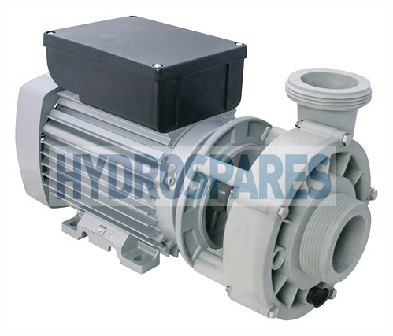
Manufactures Part No:
20-44092V2
(Replaces 20-44092 &
Spa Form 95-44092-SF
Flat Gasket required)

Description
This unique pump offers excellent flow performance for large whirlpool applications and spas with multiple features and jets.
Therapy and filtration in one. The 2-speed Magnaflow pump can be used for therapy at high speed and filtration at low speed.
Also available in single speed versions (20-4409V2 & 20-44091V2)
Specifications

- 2 speed 2Hp 1.5KW motor (0.5HP Slow & 1.5HP High)
- 230V 50Hz
- RPM 1400 Slow & 2900 High
- Qmax 11 m3h Slow & 26m3h High
- Hmax 3m Slow & 11m High
- Center suction / radial side discharge orientation
- Suction Port: . . . . . . . 2” Buttress thread ( Measures 78mm across the threads with approx 2” bore)
- Discharge Port: . . . . . 2” Buttress thread ( Measures 78mm across the threads with approx 2” bore)
- Supplied with 2 drain plugs
- Supplied with 2 m cable bare ends with ferules
- IPX5 Extruded aluminium motor
- Length x Height x Width = 390mm x 220mm x 178mm

Pump performance curves
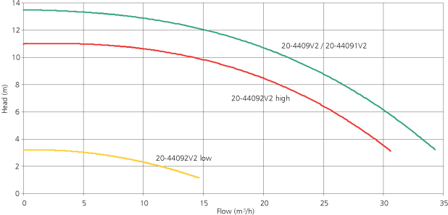

Features
Drain connections
The pumps are supplied with center suction and 2 drain connections to ensure total drainage when emptying the whirlpool or spa
Approvals
The Magnaflow 440 pumps are TÜV approved according to European norms EN60335-1 and EN60335-2-41 with focus on EN60335-2-60 where relevant.
Help & Advice
A very common pump found on many makes of hot tubs in the UK, especially Spa-Form which carried their own part code 95-44092-SF
The current pump model (Version 2) identifiable by the V2 at the end of the part code has a slightly different ‘O’ ring arrangement for the discharge port on the wet end. This means if you are replacing an older Version 1 pump you will find upon fitting the new pump there will be no grove for the o ring to sit in, we overcome this by supplying you a special flat gasket to fit between the unions.
Associated codes = 20-44092 & Spa-Form 95-44092-SF
(also replaces older Genesis models GC150 plumbing alterations required)
Associated Refs = ITT Magnaflow HA440
Should you require any further help and advice please don’t hesitate to contact us

