Customer Name: | Your Name | Delivery Name: | Your Name
Invoice  Address: | Your Address | Delivery Address: | Your Address
Phone 1: | 01234 567 89 | Account Number:
Phone 2: |  | Customer Order Number:
Order Date: | 03 March 2023
A
B
----

R

S
C
Shape: | Square or rectangle corner radius
Spa Manufacturer: | Please specify
Model & Year: | Please specify |  | C
Dimensions: | A: 2440 mm
 | B: 2440 mm
Corner Radius: | R: 220 mm
Skirt Length: | S: 130mm
Strap Length: | C: Please specify  E.g. Total length = 250mm (120mm below skirt) + clip.
Strap Qty: | 4
Strap Position  Parallel to hinge  Corners  X | E:
Colour: | Brown / Charcoal Grey / Tan  (Please delete other 2)
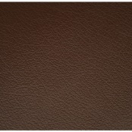 |  | E1 | E2
Notes
5-3” Drop  Encapsulated core |  | Order No:  Proforma No:

